# Department of Computer Science and Engineering

# Data Science

**Academic Year: 2022-2023 Name of Student: Arya Patil**

**Semester: III Student ID: 21107009**

**Class / Branch: SE Data Science Date Of Performance: 08/08/2022**

**Subject: Data Structure Date Of Submission: 09/08/2022**

**Name of Instructor: Prof. Anagha Aher**

# Assignment No. 1

**Question 1:**- Write a Program to print any 10 numbers using an array

**Program**

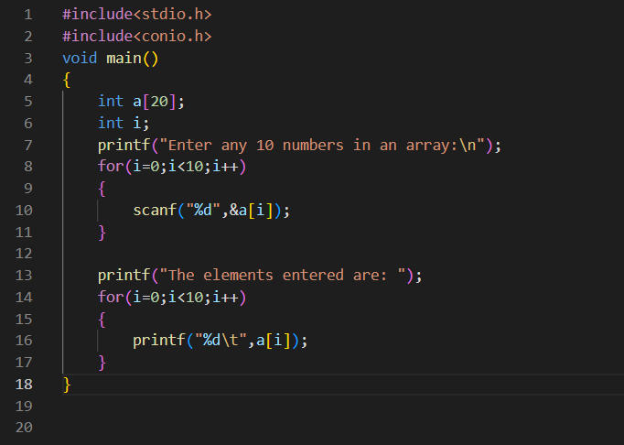

**Output:-**

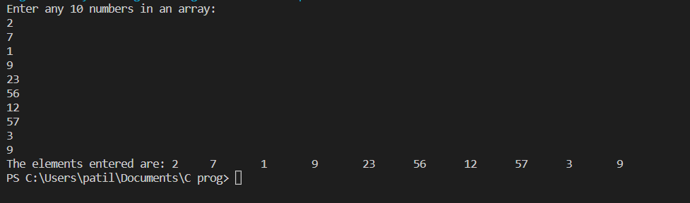

**Question 2:-** Write a Program to find min and max from array

**Program:**

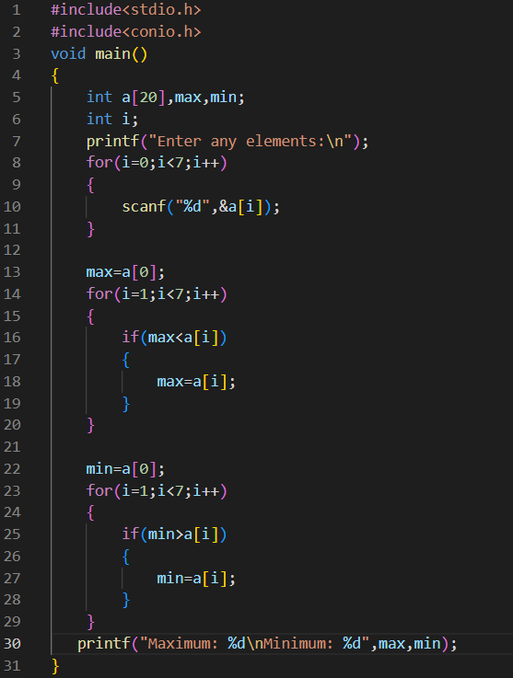

**Output:**

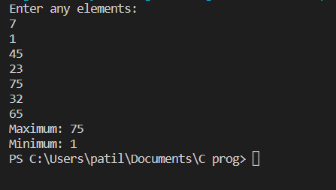

**Question 3:** Write a Program to swap 2 numbers using function call by value and call by reference.

**Program:**

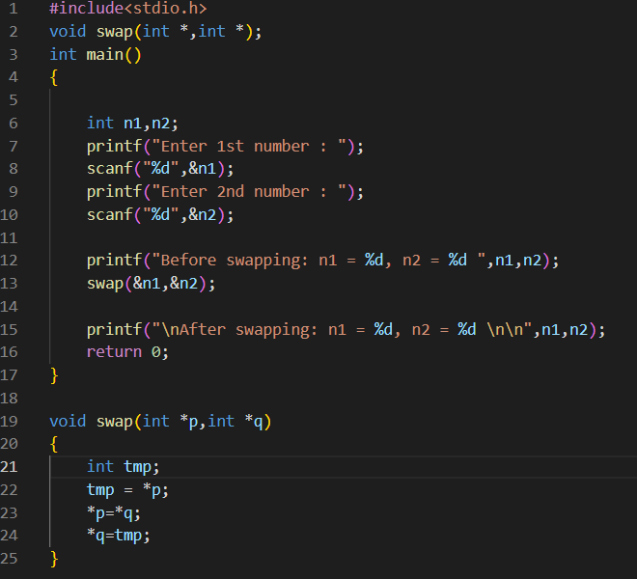

**Output:**

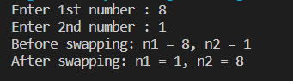

**Question 4:** Write a program for accepting the information of employee work in a company and calculate its gross salary using formula Gross= basic salary + DA + HRA.

**Program:**

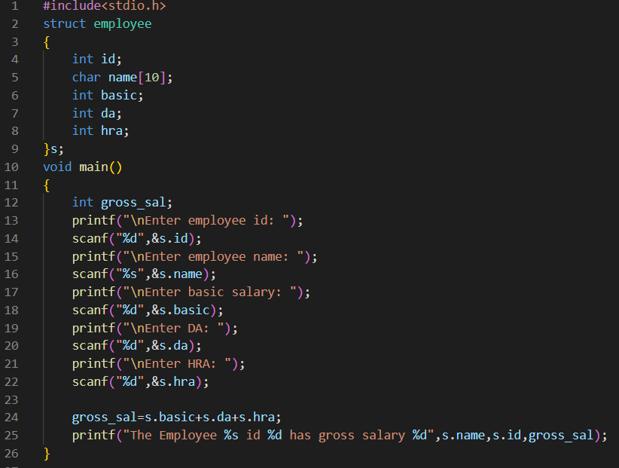

**Output:**

